Project Title
Smart Companion Pillow


Sponsors


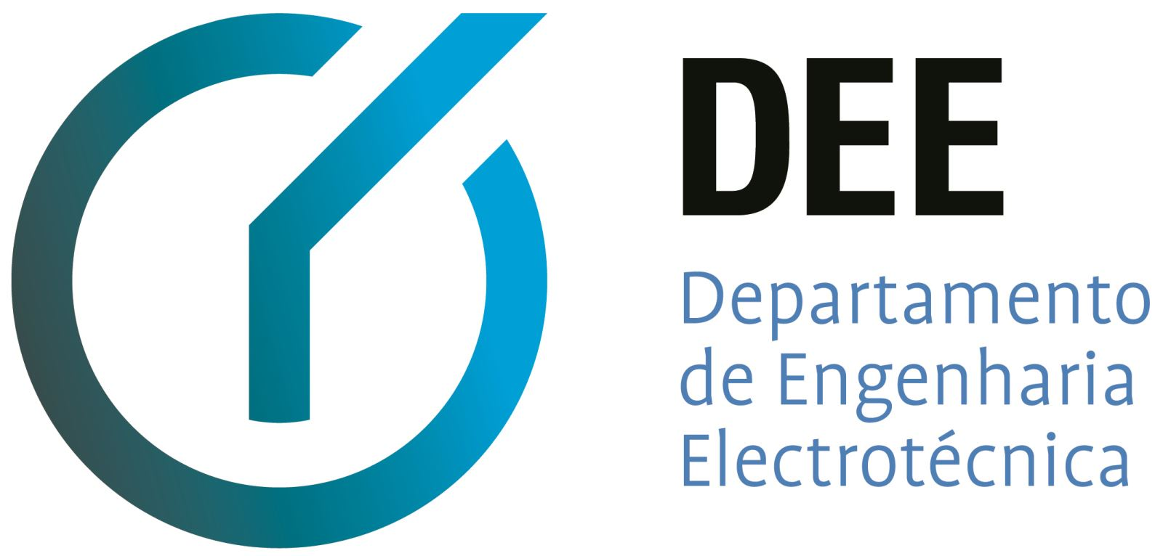










Supporters






Project Summary
The goal is to design, build and test a pet-like pillow to provide company, monitor, interact and stimulate individuals, following sustainable and ethical practices. The purpose, target user segment and the full set of device requirements are to be defined by the team based on the state of the art, marketing, sustainability and ethical analyses.
The project requirements are:
- Use or reuse low cost hardware solutions;
- Comply with the following EU Directives:
  - Machine Directive (2006/42/EC 2006-05-17);
  - Electromagnetic Compatibility Directive (2004/108/EC 2004 12 15);
  - Low Voltage Directive (2014/35/EU 2016-04-20);
  - Radio Equipment Directive (2014/53/EU 2014-04-16);
  - Restriction of Hazardous Substances (ROHS) in Electrical and Electronic Equipment Directive (2002/95/EC 2003-01-27);
- Mandatory adoption and use of the International System of Units (The NIST International Guide for the use of the International System of Units)
- Use open source software and technologies.
Maximum budget to build a prototype: 100.00 €

Participants
Institution: Instituto Superior de Engenharia do Porto (ISEP)
Team N.: 4
Students:
- Alexandre Reis;
- Elien Gielen;
- Ko Wopereis;
- Marcel Pasternak;
- Tobias Schneider;
- Vaido Sooäär.
Panel of Supervisors:
- Abel Duarte (ajd 'at' isep 'dot' ipp 'dot' pt);
- Jorge Justo (jfj 'at' isep 'dot' ipp 'dot' pt);
- Maria Benedita Malheiro (mbm 'at' isep 'dot' ipp 'dot' pt);
- Maria Cristina Ribeiro (mcr 'at' isep 'dot' ipp 'dot' pt);
- Manuel Silva (mss 'at' isep 'dot' ipp 'dot' pt);
- Paulo Ferreira (pdf 'at' isep 'dot' ipp 'dot' pt);
- Pedro Barbosa Guedes (pbg 'at' isep 'dot' ipp 'dot' pt).

Contents
Home: Project, Sponsors, Participants, Utilities and Acknowledgementss
Planning: Deadlines, Gantt Chart, Sprint Outcomes and Sprint Evaluations
Logbook: Weekly Reports and Meetings with the Supervisors
Deliverables: Links to all Deliverables
Report: Detailed Report
About EPS: The European Project Semester

Contacts
- Alexandre Reis (alexandre 'dot' soares 'dot' reis 'at' gmail 'dot' com)
- Elien Gielen (eliengielen98 'at' gmail 'dot' com)
- Ko Wopereis (kowopereis 'at' gmail 'dot' com)
- Marcel Pasternak (pasternak 'dot' marcel1 'at' gmail 'dot' com)
- Tobias Schneider (tobias 'dot' schneider96 'at' gmail 'dot' com)
- Vaido Sooäär (svaido17 'at' gmail 'dot' com)

Utilities
- DokuWiki Syntax
- Videos on how to use DokuWiki

Acknowledgements
- Teachers and Supervisors who did their very best to the success of this project.
- Sponsors: A Central da Borracha (pillow foam); Departamento de Engenharia Electrotécnica (DEE), ISEP (electronic components); Departamento de Física (DFI), ISEP (electronic components); Flexitex (pillow and sock cover), Molarte (zippers, velcro and labour to build the pillow); Laboratório de Sistemas Autónomos (LSA), ISEP (raw material and the use of a 3D printer); SOLIUS (electronic components).
- Supporters: Citeve (technical support on advanced textiles); Fibran (pillow thermal insulation board); LMA (waterproof but not airproof textile to protect the electronic components of the pillow and the sock from spillage of liquids).
- Eng.º Vítor Costa Cerqueira, DEE, ISEP (wiki installation and management)
- Prof. João Correia Lopes, Departamento de Engenharia Informática (DEI), Faculdade de Engenharia da Universidade do Porto (FEUP) (wiki template)
— EPS@ISEP Wiki Template 2012-01-15 15:35

